Project Timeline

Project Summary
Report Date | Project Name | Prepared By
16-05-2025 | SURGE | VISHAL

Status Summary
Python web application that lets users draw and analyze 2D/3D truss (and eventually arch‑truss) structures via OpenSees.

Foundation & Core Workflow
task | notes
OpenSees Truss Workflow and Core Concept | - Model Commands  - Analysis Commands  - Output Commands  - Misc. Commands  element('truss'), node(), fix(), load(), analyze())
Web App Flask | - Receive JSON truss data (nodes, elements, loads)  - Generate OpenSees scripts dynamically  - Execute OpenSees and capture outputs

User Interface
task | notes
2D Truss Builder | - Material properties (E, A)  - Connections  - Loads (point loads at nodes)  - Dropdown for units (SI/Imperial)
Data Format | - Nodes: { id, x, y, [z] }  - Elements: { id, type, iNode, jNode, area, E, [I], [curvatureParams] }  - Supports: { nodeID, ux, uy, [uz, rx, ry, rz] }  - Loads: { nodeID or elementID, fx, fy, [fz], mx, my, mz }  - Analysis Settings: { dimensionality, solver, tolerance, maxIter }
Result Visualization | Displacements, reactions, element forces, eigenvalues.

Scalability
task | notes
Advanced Features | - long analyses  - Real-Time Plotting: Plotly.js for force diagrams  - Export/Import: Save/load truss configurations
- Backend: Flask (lightweight) + Celery
- Frontend: React + Fabric.js (2D)
- Visualization: Plotly.js, D3.js

Expand to 3D
task | notes
3D Integration | - Add z-coordinate inputs  - Extend OpenSees scripts with ndm 3

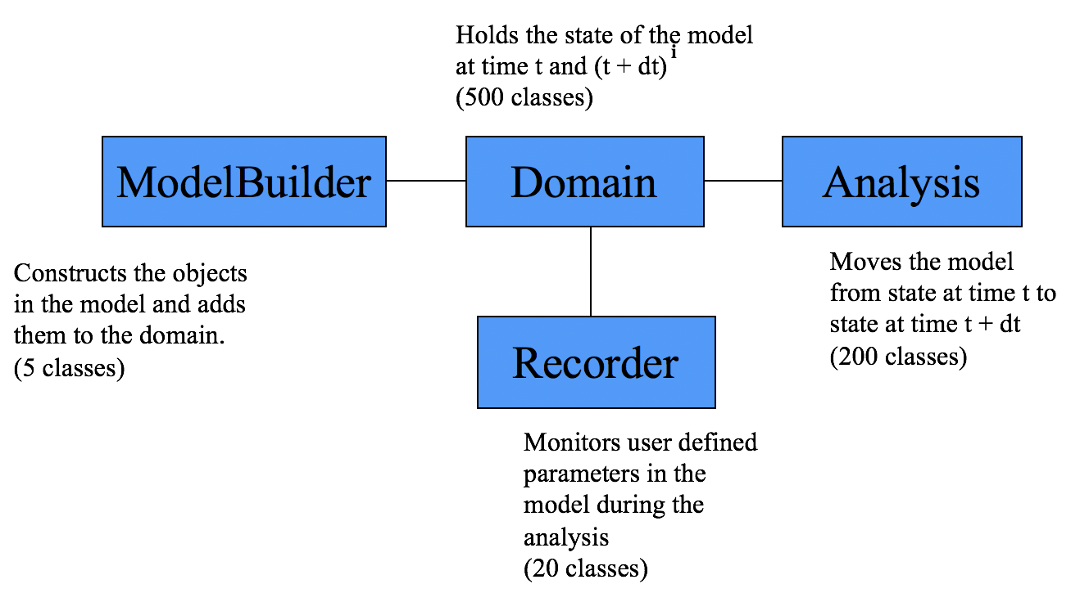

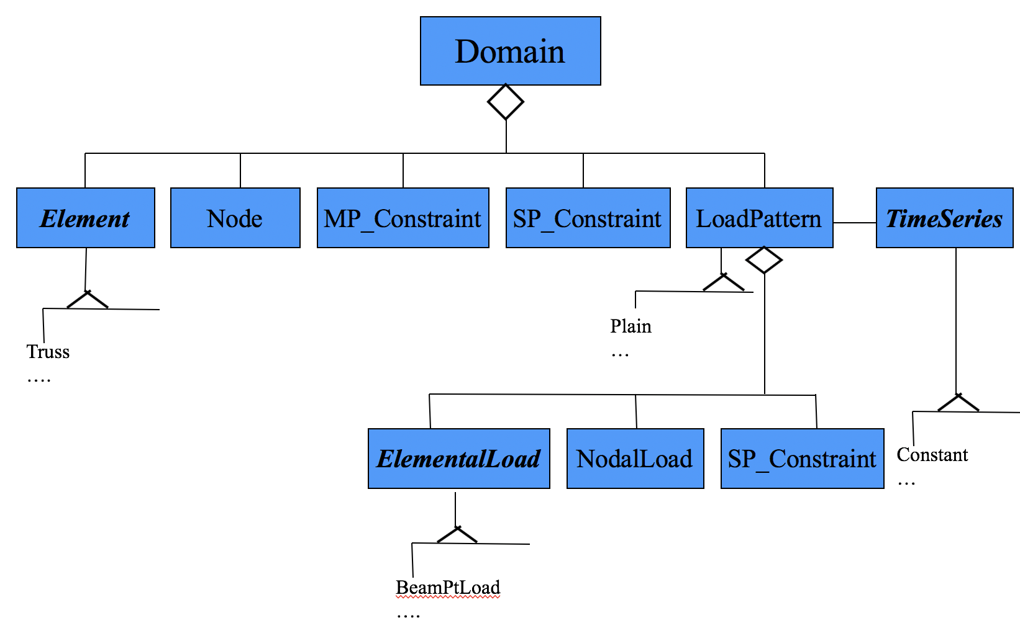
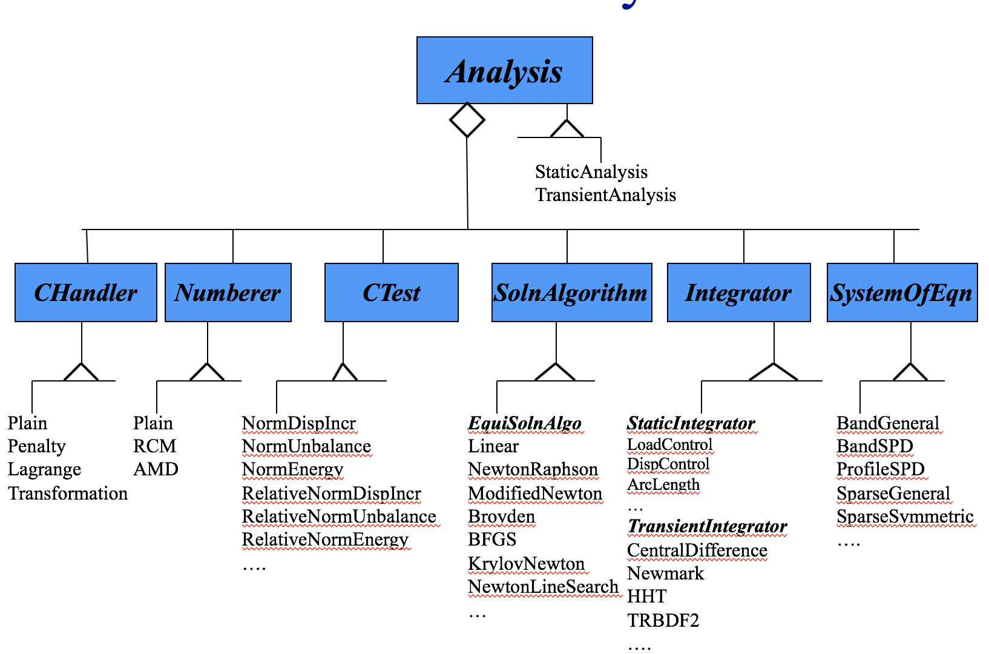

Study

research paper
A review of graphical user interfaces of OpenSees software framework
Nonlinear Finite-Element Analysis Software Architecture Using Object Composition
Software Patterns for Nonlinear Beam-Column Models
Object-Oriented Finite Element Programming: Frameworks for Analysis, Algorithms and Parallel Computing

Direct stiffness matrix method (Link)

Openseespy Library basics (Link)
Quick and Easy 2D Truss Analysis
OpenSeesPy Frame Analysis

